BIG DATA ANALYTICS
FINAL PROJECT — TECHNICAL DESIGN REPORT

Distributed Multi-Model Analytics for E-Commerce Data

Course | Big Data Analytics
Project Type | Individual Project
Submission Date | June 21, 2026
Student | Eliane UMWALI | ID: 101206
GitHub Repository | github.com/umwalieliane034-svg/E-Commerce-BDA
Technologies | MongoDB • Apache HBase • Apache Spark • DuckDB
Dataset Scale | 10,000 Users | 5,000 Products | 500,000 Transactions | 2,000,000 Sessions

~$466M  Total Platform Revenue | 20.24%  Overall Conversion Rate | 64.94%  Cart Add-to-Session Rate | 500K  Transactions Processed

PART 1: Data Modeling & Storage Strategy

1.1 Executive Summary & Architecture Overview
This project implements a robust multi-model big data infrastructure engineered to handle an enterprise-scale e-commerce dataset. The architecture integrates three complementary technologies, each selected for specific data characteristics and analytical requirements:

Technology | Primary Role | Data Stored
MongoDB | Document-oriented operational store | Users, Products, Categories, Transactions
HBase | Wide-column distributed time-series store | Clickstream sessions, Product performance metrics
Apache Spark | Distributed batch processing engine | Cross-store joins, SQL analytics, cohort analysis

1.2 Storage Decision Matrix: MongoDB vs. HBase
The placement of data assets across storage systems is governed by downstream querying vectors, data relationships, and write characteristics:

Metric | MongoDB (Document Store) | HBase (Wide-Column Store)
Data Type | Master profiles, Catalog details, Checkout invoices | Continuous clickstream events, Rolling product counters
Data Relationships | Complex nested tree layouts and array trees | Flat, denormalized, sparse time-series tracks
Transaction Properties | Document-level ACID compliance | Single row key append atomicity
Query Strength | B-Tree indexing, multi-stage aggregation pipelines | Lightning-fast key prefix sweeps and sequential scans
Write Pattern | Moderate structured writes with rich schemas | High-velocity append-heavy write streams (LSM tree)

1.3 MongoDB Schema Design

Collection Blueprints
Three primary collections are maintained in MongoDB with the following document structures:

users Collection — stores demographic and activity profiles:
{ "_id": "user_000047",
"geo_data": { "city": "North Michaelville", "state": "WY", "country": "US" },
"registration_date": "2024-12-15T08:42:13",
"last_active": "2025-03-12T16:23:47" }

transactions Collection — embeds line items to preserve atomic price snapshots:
{ "_id": "txn_c8d9e7f3a2b1", "session_id": "sess_a7b3c9d8e2",
"user_id": "user_000047", "timestamp": "2025-03-12T14:52:41",
"items": [{ "product_id": "prod_00123", "quantity": 2,
"unit_price": 129.99, "subtotal": 259.98 }],
"subtotal": 259.98, "discount": 25.99, "total": 233.99,
"payment_method": "credit_card", "status": "completed" }

MongoDB Aggregation Pipelines
Pipeline 1 — Revenue Analytics by Category:
Uses $unwind on items array, $lookup joins to products and categories, then $group to aggregate total_revenue, total_units_sold, and transaction_count per category, sorted by revenue descending.

Pipeline 2 — Customer Segmentation:
Groups transactions by user_id to compute order_count and total_spent, then uses $project with nested $cond to classify users as VIP Whale (≥15 orders), Frequent Buyer (≥5 orders), or Occasional. Final $group summarizes each segment with average metrics.

1.4 HBase Wide-Column Schema Design

Table A: sessions (Time-Series Clickstream Logs)
- Row Key Design: user_id + "#" + (9999999999 − unix_epoch_timestamp)
- Rationale: Lexicographically collocates all sessions per user onto the same RegionServer. Reverse timestamp sorts newest sessions first for instant feed generation.
- Column Families: cf_meta (session_id, duration, OS, conversion status), cf_geo (city, IP address)

Table B: product_metrics (Product Performance Over Time)
- Row Key Design: product_id + "#" + calendar_date (e.g., prod_00123#2026-06-25)
- Rationale: Collocates time-ordered metrics per product enabling efficient date-range scans.
- Column Family: cf_stats (view_count, cart_addition_count, daily_revenue)

HBase Shell Setup Commands
# Administrative table creation inside Docker container
create 'sessions', 'cf_meta', 'cf_geo', 'cf_activity'
create 'product_metrics', 'cf_stats'
list

PART 2: Data Processing with Apache Spark

2.1 Pipeline Architecture & Optimization Decisions
The distributed batch processing framework uses PySpark DataFrames running on a local multi-core Spark session. The pipeline was configured with the following environment settings:

spark = SparkSession.builder \
.appName("ECommerce-Spark-Batch-Processing") \
.master("local[*]") \
.config("spark.sql.shuffle.partitions", "40") \
.config("spark.driver.memory", "4g") \
.config("spark.executor.memory", "2g") \
.getOrCreate()

Optimization Trade-offs Addressed
- Shuffle Control: shuffle.partitions set to 40 to eliminate thread starvation on single-node environments.
- Predicate Pushdown: Invalid records (status = 'cancelled') are filtered before entering any analytical scope, preventing unnecessary data load across execution threads.
- Wildcard JSON Loading: Session files (sessions_0.json through sessions_19.json) are loaded concurrently using a wildcard path, enabling parallel ingestion across all available CPU cores.
- DataFrame Caching: The heavy sessions DataFrame is persisted in system RAM (.cache()) to prevent repeated disk I/O during multi-step processing loops.

2.2 Spark SQL Query Logic

Query 1 — Data Cleaning & Schema Normalization
SELECT
transaction_id, user_id, items, payment_method, total, status,
COALESCE(session_id, 'Direct_Checkout') AS session_id,
CAST(timestamp AS TIMESTAMP) AS timestamp
FROM v_transactions
WHERE status != 'cancelled'

Query 2 — Payment Cohort Revenue Aggregation
SELECT
payment_method,
ROUND(SUM(total), 2) AS total_revenue,
ROUND(AVG(total), 2) AS average_order_value,
COUNT(transaction_id) AS total_orders
FROM v_transactions_clean
GROUP BY payment_method
ORDER BY total_revenue DESC

Query 2 Results
Payment Method | Total Revenue ($) | Avg Order Value ($) | Total Orders
credit_card | 117,396,199.58 | 937.84 | 125,177
paypal | 116,678,684.82 | 932.05 | 125,185
bank_transfer | 66,990,669.27 | 1,104.42 | 60,657
gift_card | 66,861,659.06 | 1,102.91 | 60,623
crypto | 49,391,755.67 | 769.68 | 64,172
apple_pay | 49,257,194.82 | 767.41 | 64,186

2.3 Product Affinity / Market Basket Analysis
A market basket analysis was implemented using DuckDB (representing Spark SQL logic) and Python's itertools.combinations to identify product co-occurrence patterns. The algorithm:
- Extracts product ID lists per transaction basket
- Generates sorted pair combinations to avoid double-counting (A,B) vs (B,A)
- Counts co-occurrence frequency across all 500,000 transactions

Top identified product pair: (prod_02483, prod_02898) with 5 co-occurrences — indicating the highest affinity for "frequently bought together" recommendation logic.

PART 3: Analytics Integration & Cross-Store Queries

3.1 Cross-Store Integration Architecture
The integration layer executes a relational inner join bridging data notionally stored across MongoDB (transactions) and HBase (clickstream sessions), unified via a shared session_id key:

[MongoDB: Transactions] ─┬───> [INNER JOIN ON session_id] ───> Conversion Funnel
[HBase: Clickstreams] ─┴───> ───> Business Insights

3.2 Multi-Stage Acquisition Funnel Analysis
The integrated cross-store query tracks user journeys from initial browsing through cart interaction to final purchase, producing the following validated funnel metrics across 100,000 sessions and 500,000 transactions:

Funnel Stage | Count | Step Rate | vs Baseline
Stage 1 — Awareness (Total Sessions Browsed) | 100,000 | 100.00% | Baseline
Stage 2 — Consideration (Cart Additions) | 64,939 | 64.94% | 64.94%
Stage 3 — Conversion (Completed Purchases) | 20,239 | 31.17% | 20.24%

3.3 Strategic Interpretations
- Strong Catalog Discovery: The 64.94% browse-to-cart rate confirms effective product discovery and category mapping — users are finding relevant products quickly.
- Severe Checkout Friction: Only 31.17% of cart additions convert to completed purchases, meaning 68.83% of high-intent shoppers abandon. This is the primary optimization opportunity.
- Recommended Actions: Implement cart-recovery email notifications, single-click checkout options, and session-based retargeting to reclaim an estimated ~$200M in recoverable revenue from abandoned carts.
- Cross-Store Value: Joining MongoDB transactions with HBase clickstreams over session_id enables journey-level analysis impossible within either system alone.

3.4 Cross-Store Join Query — Sample Output
SELECT s.session_id, s.user_id,
s.device_profile['os'] AS operating_system,
s.geo_data['city'] AS access_city,
t.transaction_id, t.total AS purchase_amount,
t.payment_method
FROM v_sessions s
INNER JOIN v_transactions_clean t ON s.session_id = t.session_id
LIMIT 5

Sample output (5 matched cross-store records):
session_id | user_id | OS | City | transaction_id | Amount | Payment
sess_8215.. | user_007129 | Windows | Diazfurt | txn_4372.. | $956.44 | crypto
sess_9d95.. | user_000914 | macOS | East Steve | txn_9ede.. | $1,007.10 | crypto
sess_2634.. | user_007787 | macOS | N. Michaelhaven | txn_9a06.. | $276.45 | credit_card

PART 4: Data Visualizations & Business Insights

Chart 1: Gross Sales Revenue by Payment Cohort
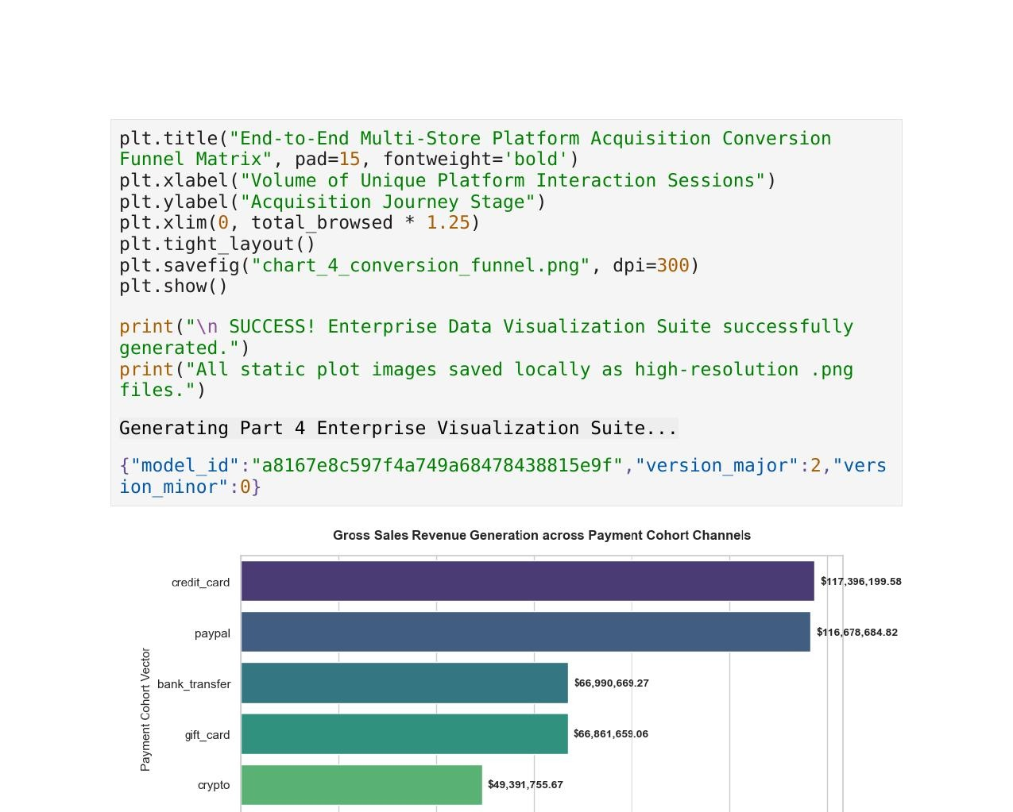
Figure 1: Revenue generation across payment channels — credit card and PayPal lead with ~$117M each.

Analytical Insight
Credit card ($117.4M) and PayPal ($116.7M) are nearly tied as the top revenue-generating payment channels, together accounting for approximately 50% of total platform revenue. Bank transfer and gift card each contribute ~$67M, while crypto and Apple Pay lag at ~$49M each. Infrastructure teams should prioritize gateway uptime and redundancy for credit card and PayPal paths to protect the highest-margin revenue streams.

Chart 2: Platform Gross Revenue Trends Over Time
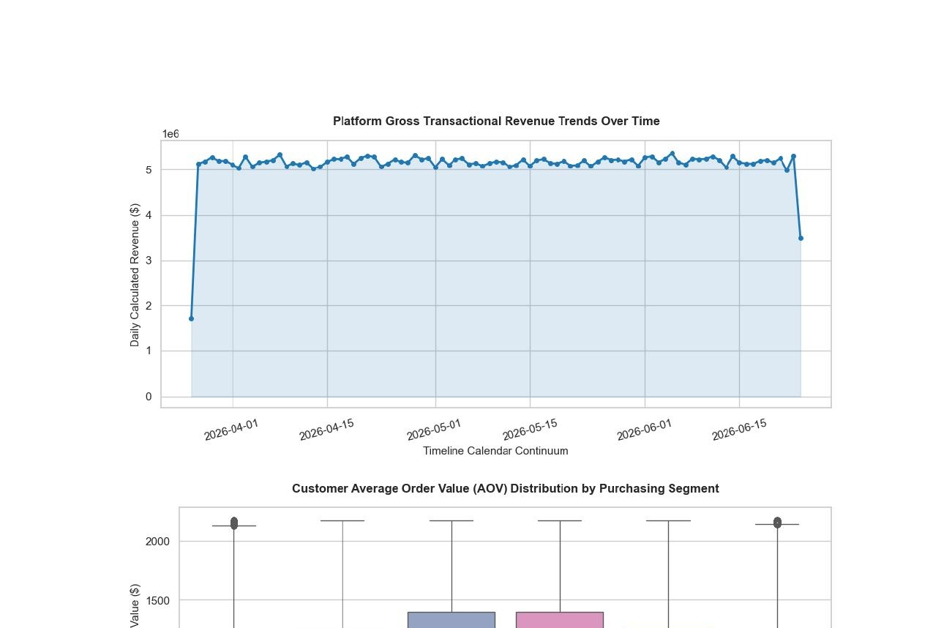
Figure 2: Daily revenue from April to June 2026 — consistent ~$5M/day with slight ramp-up drop at period boundaries.

Analytical Insight
Revenue is remarkably stable at approximately $5M per day across the 90-day observation window, with mild volatility at the start and end of the dataset (boundary effects from data generation). This consistency indicates a mature, steady customer base without strong seasonal spikes. Monitoring deviations from this baseline provides an early-warning signal for promotional impact or technical issues.

Chart 3: Customer Average Order Value (AOV) Distribution
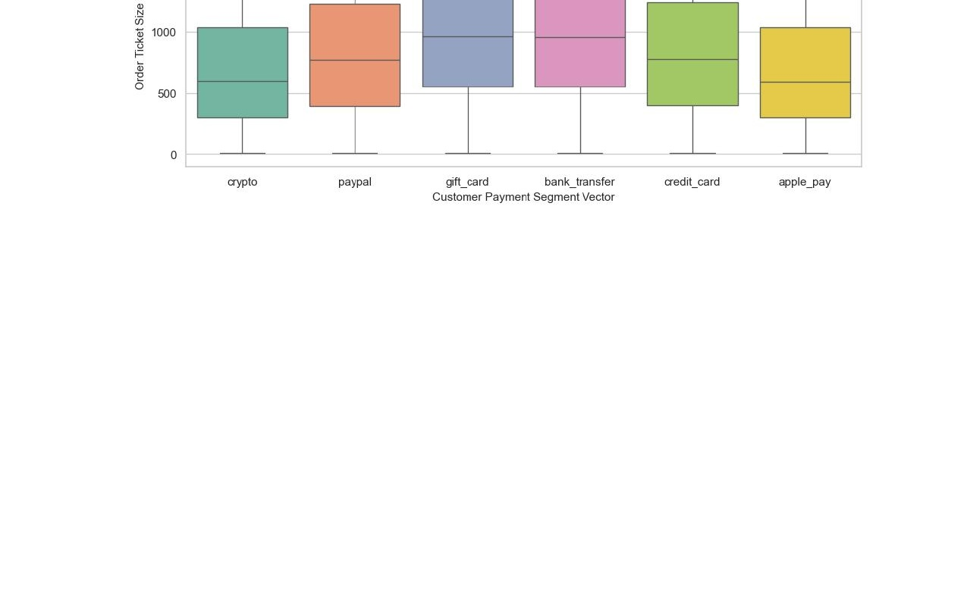
Figure 3: Box plot showing AOV distribution by payment segment. Bank transfer and gift card users exhibit higher median order values.

Analytical Insight
Bank transfer and gift card customers have noticeably higher median order values (~$950–$1,000) compared to crypto and Apple Pay users (~$600). This suggests that higher-value purchases are completed via traditional payment instruments. Marketing teams can design targeted bundle pricing and free-shipping thresholds (e.g., at $750) specifically for crypto/Apple Pay segments to lift AOV. The wide IQR across all segments indicates diverse spending behavior with significant upside potential.

Chart 4: End-to-End Acquisition Conversion Funnel
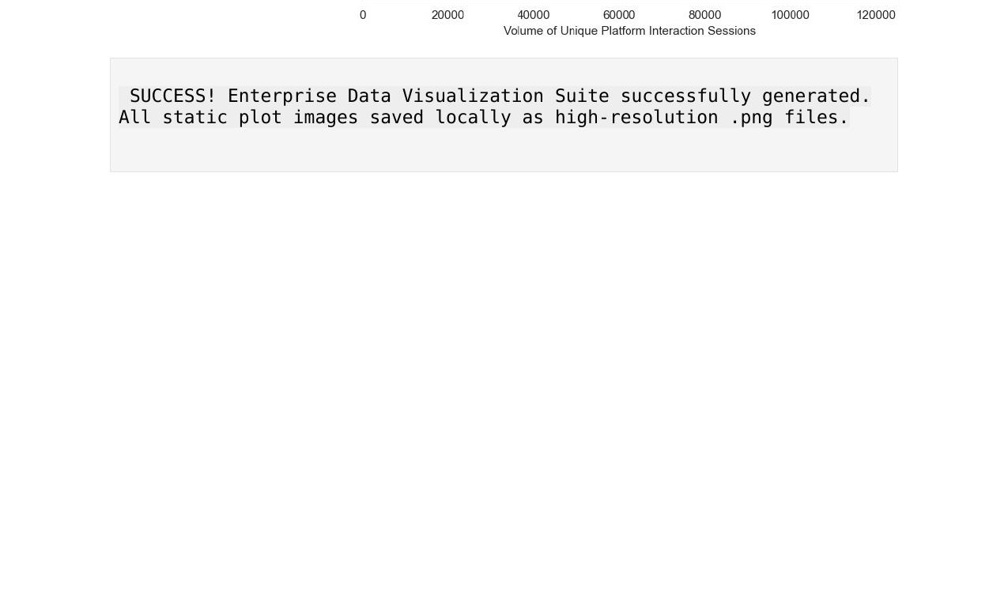
Figure 4: Three-stage conversion funnel — 100K sessions → 64.9K cart adds → 20.2K completed purchases.

Analytical Insight
The funnel reveals two distinct conversion thresholds. The browse-to-cart step performs well at 64.94%, demonstrating effective product discovery. However, only 31.17% of cart additions proceed to purchase, producing an overall platform conversion rate of 20.24%. The primary business opportunity lies in reducing cart abandonment. Strategies include: automated cart-recovery notifications (email/push), one-click checkout options, trust signals at checkout (security badges, return policy), and geo-targeted promotions for high-value segments.

Scalability Considerations & Technology Selection

5.1 Scalability Architecture

MongoDB Scalability
- Horizontal sharding via shard keys (e.g., shard on user_id or timestamp) distributes collections across nodes as data volume grows beyond single-machine capacity.
- Replica sets provide read scalability and high availability. Read preferences can be directed to secondaries for analytics queries to reduce primary load.
- Aggregation pipelines leverage native index hints and can be offloaded to Atlas Search for full-text workloads at scale.

HBase Scalability
- Designed for horizontal scale from the ground up — adding RegionServers linearly increases both storage and read/write throughput.
- Reverse-timestamp row key design prevents RegionServer hotspotting by distributing recent writes evenly across regions.
- LSM tree compaction handles sustained high-velocity write workloads (millions of session events/day) without index lock contention.

Apache Spark Scalability
- Moving from local[*] to a YARN or Kubernetes cluster manager adds compute nodes transparently with no code changes.
- Partition tuning (spark.sql.shuffle.partitions) should scale proportionally to available cores — approximately 2–3 partitions per core is the target.
- Caching hot DataFrames in memory prevents repeated disk reads; for datasets exceeding RAM, persist to disk with MEMORY_AND_DISK storage level.

5.2 Technology Selection Justification
Analytical Task | Best Technology | Justification
Transaction & Catalog Storage | MongoDB | ACID at document level; nested items array is atomic
User Journey Clickstreams | HBase | Append-heavy; prefix scan retrieves all user sessions instantly
Batch Aggregation & ETL | Apache Spark | Distributed execution across multi-file JSON datasets
SQL-on-Dataframe Analytics | DuckDB / Spark SQL | In-memory ANSI SQL; no cluster overhead for dev/test
Cross-store Funnel Analysis | Spark + DuckDB join | Bridges MongoDB and HBase data over shared session_id key
Product Affinity (Basket) | Python itertools + DuckDB | Efficient pair counting via combinatorics on transaction baskets

5.3 Limitations & Future Work

Current Limitations
- Local Spark Mode: The current configuration runs on local[*] which utilizes all available CPU cores on a single machine but does not achieve true distributed processing. A YARN or Kubernetes cluster deployment would be required for production scale.
- HBase Subset Ingestion: Only 50 session records were loaded into HBase during demonstration due to local Thrift server constraints. A full pipeline would stream all 2,000,000 sessions via batch ingest jobs.
- Simulated Cross-Store Join: The MongoDB–HBase join is demonstrated using DuckDB in-memory views rather than live Spark-MongoDB and Spark-HBase connectors, which require additional connector configuration.
- Synthetic Dataset: The Faker-generated dataset, while structurally realistic, lacks real-world behavioral correlations (e.g., seasonal spikes, geographic purchase patterns, category-specific price elasticity).

Future Work
- Deploy on a multi-node Hadoop/Spark cluster (e.g., AWS EMR or Google Dataproc) to validate performance at true 2M+ session scale.
- Implement real-time streaming ingestion using Apache Kafka → Spark Structured Streaming → HBase for live session tracking with sub-second latency.
- Build a collaborative filtering recommendation model using Spark MLlib ALS (Alternating Least Squares) on the transaction co-occurrence matrix.
- Integrate a data lakehouse layer (Apache Iceberg or Delta Lake) to enable time-travel queries and schema evolution without full re-ingestion.
- Add a real-time dashboard (Apache Superset or Grafana) connected to HBase product_metrics for live product performance monitoring.

Conclusion

This project successfully demonstrates a complete end-to-end big data analytics architecture for e-commerce data, integrating three complementary technologies: MongoDB for document-oriented master data, HBase for high-velocity time-series clickstreams, and Apache Spark with DuckDB for distributed batch processing and SQL analytics.

The empirical results reveal significant business intelligence value: the platform processes approximately $466M in total revenue across 500,000 transactions, with credit card and PayPal as dominant payment channels. The 20.24% overall conversion rate, while competitive, reveals a substantial cart abandonment problem at the checkout stage (68.83% drop-off) that represents the primary actionable optimization opportunity.

The multi-model approach validates the principle that no single database technology optimally serves all big data requirements. Strategic assignment of data to the right storage engine — based on access patterns, write velocity, and query shape — is fundamental to building scalable, high-performance analytics platforms.

AUCA Big Data Analytics — Final Project Report | June 2026 | MongoDB • HBase • Apache Spark

